UTS SAFE WORK METHOD statement (SWMS)

- FACULTY/SUBJECT
Faculty/Subject title | 41013 Industrial Robotics
Subject supervisor/coordinator | Gavin Paul
SWMS prepared by | Quoc Binh NGUYEN, Mattia CANDOTTI, Lucas PLUMBOHM  ****Dinh Bach NGUYEN(
- WORK ACTIVITY DESCRIPTION
Describe the work activity E.g. Operating, Handling, Using..  Include names of hazardous equipment, substances or materials used,  and any quantities and concentrations of substance(s) or reaction products. | 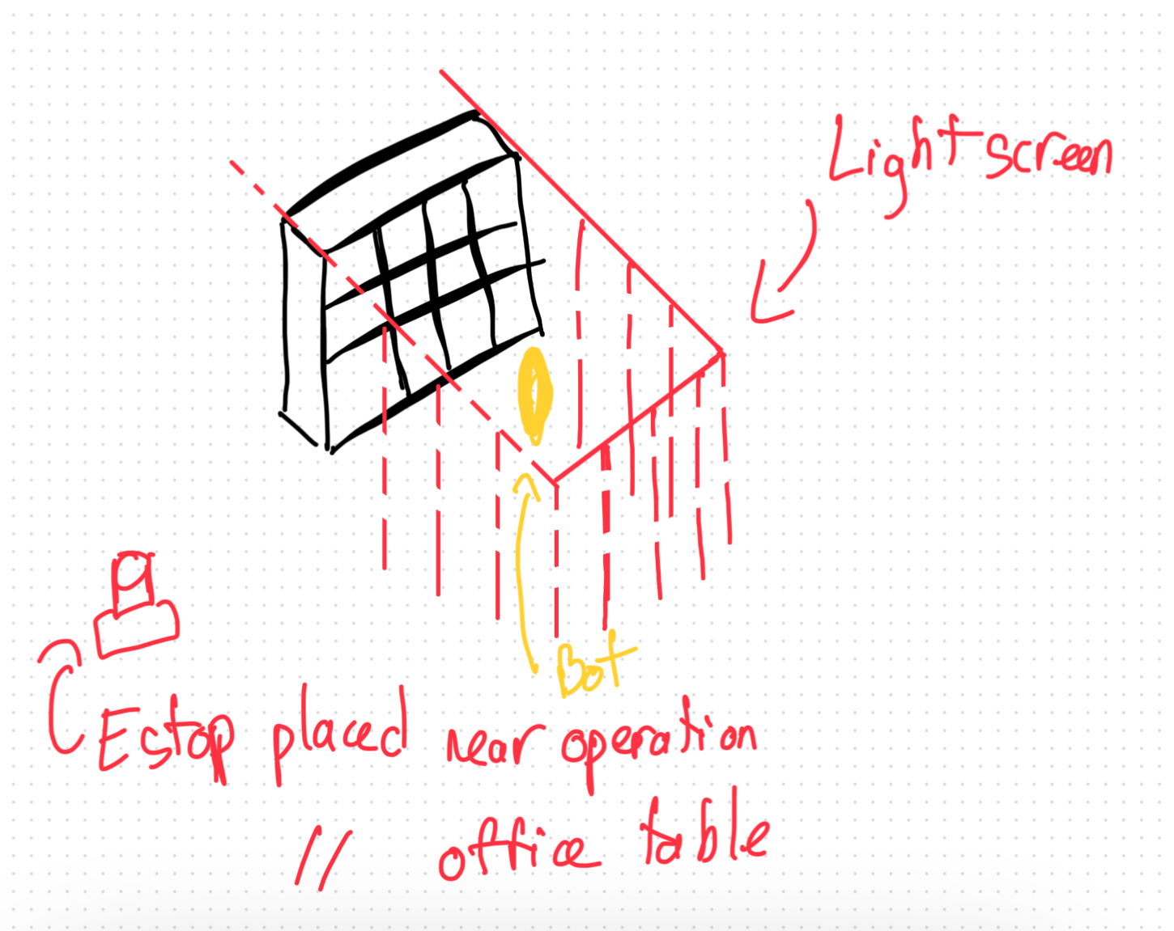  Operation of UR3 and custom Library Sorting Robot together. UR3 will operate in a smaller scale environment sorting through a series of books of varying size and colour, it’s motion will be predetermined, adjusted by a LIDAR and RGB sensing camera to determine information about the books. The Library Robot will operate on a larger scale with calculated movements. After the books have been sorted and the best fit has been determined, inverse kinematics will be used to determine the robot’s movements. Therefore, due to the nature of using a solver, the movement will be unpredictable.  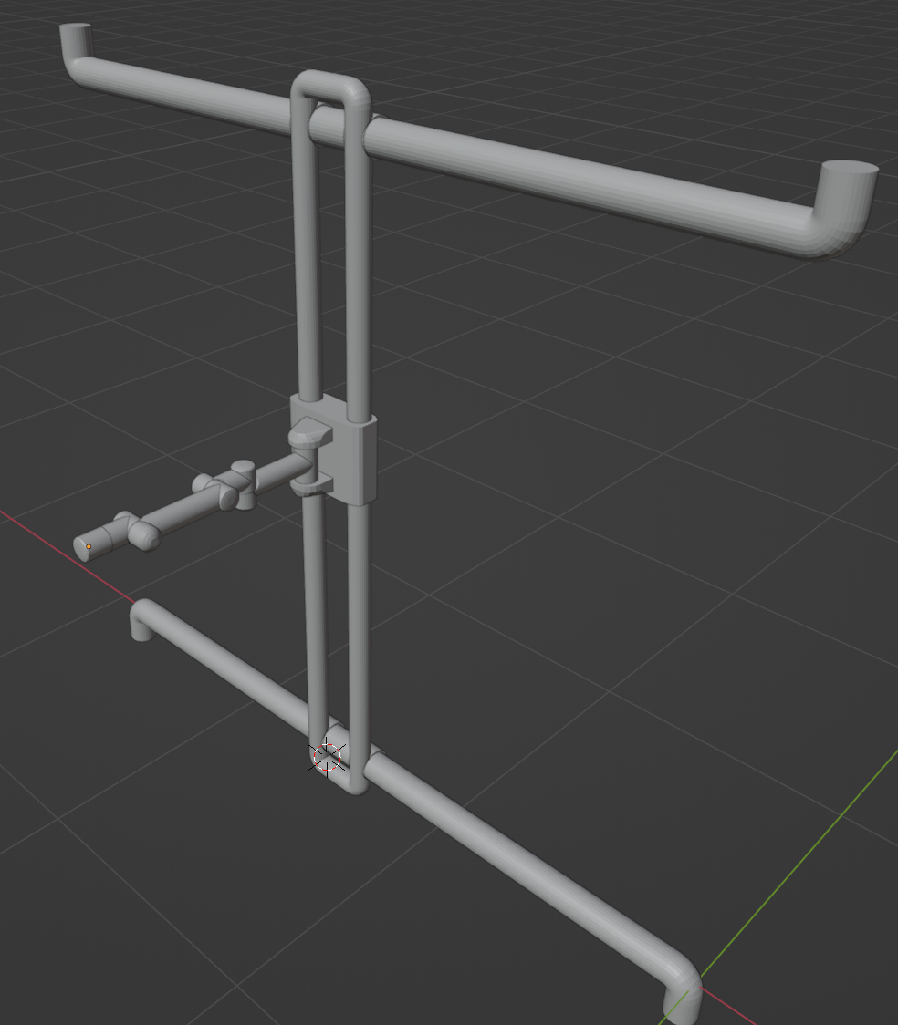  The environment will be in a “maintenance tunnel” setting, I.e: not accessible to unauthorised personnel. The exact area of operation will be sectioned off with laser based detectors that will cause the robot to initialise an E-stop should it detect any movement within the restricted area. This area will also be marked by caution tape on the ground so this area is not accidentally entered.  No extra equipment will be used outside of these two robots, the books needed to scan, and the bookshelf that they will be placed onto.
- HAZARDS: Choose those hazard types that will need to have control measures in Section 4
Work Environment  - Working in Remote Locations  - Working Outdoors/fieldwork  - Clinical/Industrial setting  - Poor ventilation/Air quality  - Temperature extremes  - Working at Height  - Slip/Trip/Fall hazards |  | Plant  - Noise  - Vibration  - Working with compressed air  - Lifts Hoists or Cranes  - Moving parts (Crushing,friction, cut, stab, shear hazards)  - Pressure Vessels or Boilers |  | Chemical  - Hazardous Chemicals use  - Skin/eye irritant  - Sensitiser  - Mutagen  - Carcinogen  - Toxic to reproduction  - Aquatic toxicity  - Toxic  - Corrosive  - Dangerous when wet |  | Ergonomic/Manual Handling  - Repetitive or awkward movements  - Lifting heavy objects  - Over reaching  - Working above shoulder or below knee height  - Poor workstation set up
Electrical  - Plug in equipment  - High voltage  - Exposed wiring  - Exposed conductors |  | Radiation  - Ionising Radiation  - Non-ionising radiation (Lasers, Microwaves, Ultraviolet light) |  | Biological  - Sharps/Needles  - Cytotoxins  - Pathogens/infectious materials  - Infectious materials  - Communicable diseases  - Animal/insects  - Work with fungi/bact/viruses |  | Psychosocial  - Aggressive or violent clients/students  - Working in isolation  - Working with timeframes  - Staffing issues
- CONTROLS MEASURES: Choose those that apply for hazards identified
Eliminate/Isolate/Substitute / Engineering Controls  - Remove hazard  - Restrict access  - Redesign equipment  - Guarding / Barriers / Fume Cupboard / exhaust  - Biosafety cabinet  - Use safer materials/substances  - Ventilation  - Regular maintenance of equipment  - Redesign of workspace / workflow |  |  | Admin specific: Licenses/permits Work Methods  - Training Information or Instruction  - Licensing or certification of operators  - Test and tag electrical equipment  - Restricted access  - Regular breaks  - Task rotation  - Work in pairs  - Document Chemical risk assessment  - Ladder / Sling register |  | Emergency Response Systems  - First aid kit  - Chemical spill kit  - Safety shower  - Eye wash station  - Emergency Stop button  - Remote Communication Mechanism
Other controls not listed
Laser based E-stop
Operation at lower speeds in exposed areas
Operation at lower speeds when robot near joint limits
Operation at lower speeds when robot near workspace limits

- PPE REQUIRED (Tick those that apply)
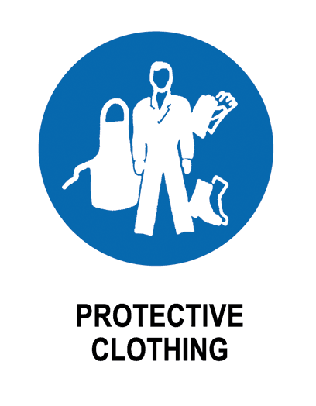


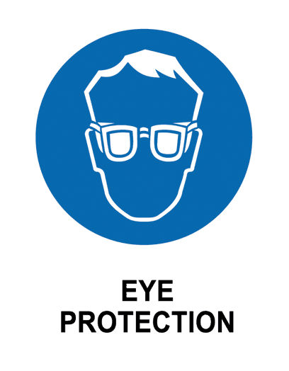

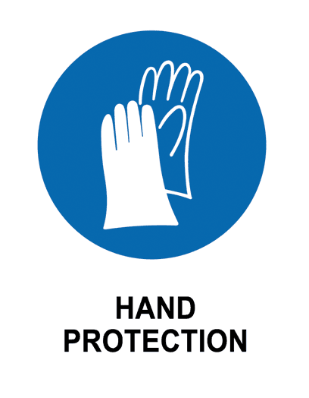

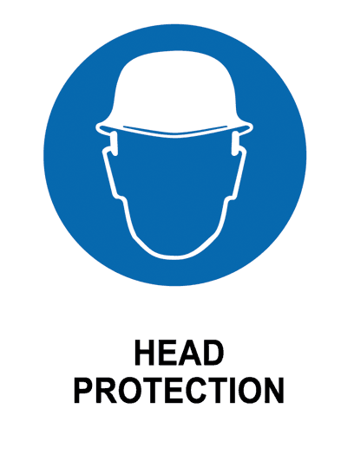
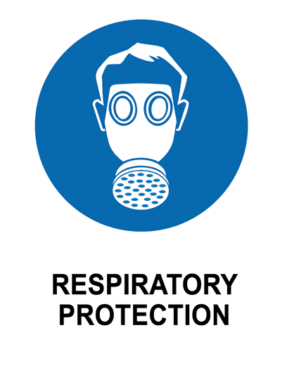
- EMERGENCY EQUIPMENT
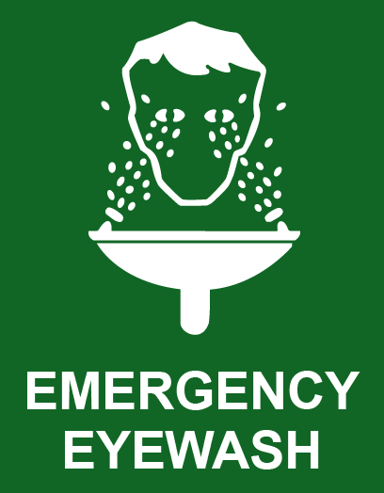
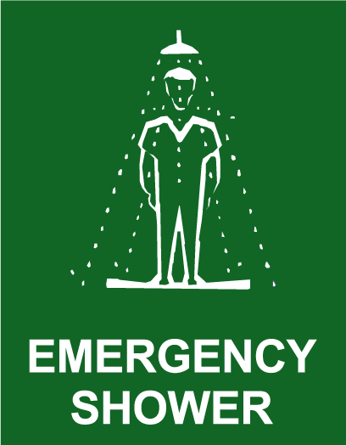
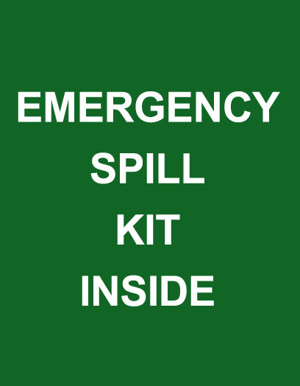

- work activity steps
before you start:

- Review Safety Protocols: Familiarise yourself with the safety guidelines and emergency procedures for operating the robotic arm.
- Inspect Equipment: Check the robotic arm and all associated equipment for any signs of wear, damage, or malfunction.
Clear the Work Area: Ensure the workspace is free of unnecessary items, and that all cables are securely fastened and out of the way.
Verify Load Requirements: Confirm that the load to be handled by the robot is within the manufacturer's specified limits.
Having a person who has access to the E-stop when in action: Put on appropriate personal protective equipment (PPE), such as safety goggles, gloves, and non-slip footwear.
Simulate trajectory before running on the robot: Make sure the trajectory is as planned and won’t cause issue to the surroundings.

steps in work activity:
Power On the Robot: Safely power on the robotic arm and connected systems, ensuring that all indicators show normal operation..
Programming/Setting Task: Input the necessary commands or select the pre-programmed task sequence on the control panel.
Execute Task: Initiate the task sequence, closely monitoring the robot's movements and performance throughout the operation.
Monitor Operation: Continuously observe the robot to ensure it is functioning correctly and that no hazards arise during operation.
Power Down and Secure: After completing the task, power down the robot and disconnect any tools or loads, then secure the equipment and work area.
emergency procedures:

- Press emergency button
- Notify security or dial 6 using the UTS internal phone

training required:

- sign off
prepared by:  NAME: SIGNED | Lab Supervisor  Name: Michael Lee | Date: 11 OCT 2024  Review Date:

